# Combined MQTT Reservoir Report

## Section 1: MQTT Assignment Overview

MQTT Client Setup: The ReservoirSubscriber class initializes an MQTT client, subscribes to   
three reservoir topics, and processes incoming messages.  
  
1. Message Handling: The on_message method decodes incoming messages and stores the   
date, reservoir name, and WML in a list (data_collected).  
  
2. Data Collection: The generate_report method converts the collected data into a Pandas   
DataFrame, averages any duplicate entries, and creates a pivot table for visualization.  
  
3. Visualization: Using Matplotlib, the code generates a line plot of WML over time for each   
reservoir, saving it as reservoir_wml_report.png.  
  
Running the Code  
  
1. Install Required Libraries: Ensure you have the necessary Python packages installed:  
  
pip install paho-mqtt matplotlib pandas  
  
2. Start MQTT Broker: Make sure you have access to an MQTT broker (like Mosquitto or a   
public broker). The example uses mqtt.eclipse.org.  
  
3. Publish Test Data: You will need to have a separate script or application to publish test WML   
data to the specified MQTT topics (SHASTA/WML, OROVILLE/WML, FOLSOM/WML). The   
  
JSON payload should look like this:  
  
{"date": "2024-10-20", "WML": 50}  
  
4. Run the Subscriber: Execute the above script. It will run for 10 seconds, collecting messages,   
and then generate a visual report.  
  
Notes:  
  
• Adjust the time.sleep(10) as needed to match how frequently your test data is published.  
  
• The visual report will be saved as a PNG file named reservoir_wml_report.png in the   
current working directory.

Visualization generated from the assignment:

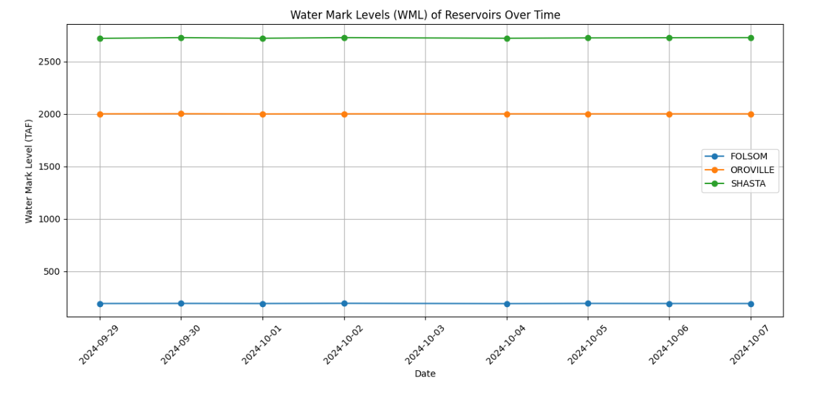

## Section 2: MQTT Data Report for California Reservoirs

This report summarizes the daily average Water Mark Levels (TAF) for the Sonoma reservoir, collected and aggregated through an MQTT-based system. The data reflects readings for a week in early October 2024, demonstrating the system's capabilities in handling and processing real-time environmental data.  
  
Date Reservoir Average TAF  
9/29/2024 Sonoma 192.0  
9/30/2024 Sonoma 193.0  
10/1/2024 Sonoma 192.0  
10/2/2024 Sonoma 194.0  
10/4/2024 Sonoma 191.0  
10/5/2024 Sonoma 193.0  
10/6/2024 Sonoma 192.0  
10/7/2024 Sonoma 192.0  
  
The data shows consistent TAF readings with minor fluctuations over the observed period. Such information is crucial for effective water resource management, especially in regions susceptible to drought and environmental variability.